Building Chemistry Together

Joe Leon

CST-451 Capstone Project Requirements Document

Grand Canyon University

Instructor: Professor Mark Reha

Revision: 3.0

Date: 4-13-19

**ABSTRACT**

Building Chemistry Together is a standalone application that will allow users to pick a element from the Periodic Table of Elements and then select where they can add it in depending on the balancing of the previous elements.

|  |
| --- |
| History and Signoff Sheet |

**Change Record**

|  |  |  |
| --- | --- | --- |
| **Date** | **Author** | **Revision Notes** |
|  |  | Initial draft for review/discussion |
| 4-14-19 | Joe Leon | Revised to include current developmen |
|  |  |  |

|  |
| --- |
| **Overall Instructor Feedback/Comments** |

|  |
| --- |
| **Overall Instructor Feedback/Comments** |

**Integrated Instructor Feedback into Project Documentation**

☐ Yes ☐ No

**TABLE OF CONTENTS**

Functional Requirements 4

Non-Functional Requirements 7

Technical Requirements 7

Logical System Design 8

User Interface Design 9

Functional Requirements

**Use Cases**

Use Case 1: setting up a new structure:

Main Flow:

1. The user will move their mouse over the element that they want to put first.
2. The user will click and hold down the mouse.
3. The system will display a 3D model of that element underneath the user’s curser.
4. The user will then drag it to the bottom half of the screen and let go of the mouse click.
5. The element will then center itself at the middle of the bottom half of the screen.

Alternate Flow

Use Case 2: Adding a new element.

Main Flow:

1. The user will move their mouse over the element that they want to add to the existing structure.
2. The user will click and hold on the icon of the element they want.
3. The system will display a 3D model of that element underneath the user’s curser.
4. The system will then display nodes along any area of the existing structure were a bond is possible.
5. The user will then drag that element to any of the displayed nodes and release their click.
6. If the element is released inside one of nodes, the element will be attached to the atomic structure.

*Alternate Flow*

1. The user will move their mouse over the element that they want to add to the existing structure.
2. The user will click and hold on the icon of the element they want.
3. The system will display a 3D model of that element underneath the user’s curser.
4. The system will then display nodes along any area of the existing structure were a bond is possible.
5. If the element is dropped outside of one of the nodes where it is able to bond, it will disappear from the view and be taken out of scope.

*Use Case 3: Removing an element.*

*Main Flow:*

1. The user will hover their mouse over the atomic structure; any elements that can be removed without causing the whole structure to fail will be highlighted as the mouse hovers over them.
2. The user will click and hold on the highlighted element and pull it away to detach it from the rest of the structure.
3. The system will then display nodes along any area of the existing structure were a bond is possible.
4. The user will then drag that element to anywhere on the screen that is not a node and let go of their click to remove the element from the view.

Use Case 4: Rearranging an element.

Main Flow:

1. The user will move their mouse over the atomic structure, any elements that can be removed without causing the whole structure to fail will be highlighted as the mouse hovers over them.
2. The user will click and hold on the highlighted element and pull it away to detach it from the rest of the structure.
3. The system will then display nodes along any area of the existing structure were a bond is possible.
4. The user will then drag the element over to the desired node.
5. If the element is released inside one of nodes, the element will be attached to the atomic structure.

Use Case 5: Creating an Ion (adding electrons).

Main Flow:

1. The user will move their mouse over the button of the element that they want to put first.
2. The user will click and hold down the mouse.
3. The system will display a 3D model of that element underneath the user’s curser.
4. The user will drag it to a node that is always available to the left side of the screen and release.
5. The system will display the number of electros in the element’s outer electron cloud.
6. The user will click on a plus button located to the top right of the node to add the desired amount of electrons.
7. The user will hover over the node and click and hold down the mouse to drag the modified element to the desired node.

Use Case 6: Creating an Ion (subtracting electrons).

Main Flow:

1. The user will move their mouse over the button of the element that they want to put first.
2. The user will click and hold down the mouse.
3. The system will display a 3D model of that element underneath the user’s curser.
4. The user will drag it to a node that is always available to the left side of the screen and release.
5. The system will display the number of electros in the element’s outer electron cloud.
6. The user will click on a minus button located to the top right of the node to subtract the desired amount of electrons.
7. The user will hover over the node and click and hold down the mouse to drag the modified element to the desired node.

Use Case 7: Creating an Isotope (adding neutrons).

Main Flow:

1. The user will hover their mouse over the element that they want to put first.
2. The user will click and hold down the mouse.
3. The system will display a 3D model of that element underneath the user’s curser.
4. The user will drag it to a node that is always available to the left side of the screen and release.
5. The system will display the number of electros in the element’s outer electron cloud.
6. The user will click on a plus button located to the bottom right of the node to add the desired amount of neutrons.
7. The user will hover over the node and click and hold down the mouse to drag the modified element to the desired node.

Use Case 8: Creating an Isotope (subtracting neutrons.)

Main Flow:

1. The user will move their mouse over the button of the element that they want to put first.
2. The user will click and hold down the mouse.
3. The system will display a 3D model of that element underneath the user’s curser.
4. The user will drag it to a node that is always available to the left side of the screen and release.
5. The system will display the number of electros in the element’s outer electron cloud.
6. The user will click on a minus button located to the bottom right of the node to subtract the desired amount of neutrons.
7. The user will hover over the node and click and hold down the mouse to drag the modified element to the desired node.

Use Case 9: Save Project

Main Flow:

1. The user will click on the file drop down menu.
2. The user will click on the Save Project option.
3. The user will determine where the saved project is going to be created at.
4. The system will use a existing folder inside the program’s files as a default storage.
5. The system will create an xml file and add a string at the top of the file to indicate that it was made with BCT.
6. The system will take all existing elements from the project and store the id of the element, its X,Y,Z position, its number of electrons, its number of neutrons, and what is bonded to inside the save file.
7. The system will close the window and display the main page.

Use Case 10: Load Project

Main Flow:

1. The user will click on the file drop down menu.
2. The user will click on the Load Project option.
3. The user will locate the xml save file they wish to use.
4. The system will check the xml file to see if it is comparable with BCT.
5. If the file is loaded correctly, the system will assemble the atomic structure based on the configuration within the xml save file.

Alternate Flow

1. The user will click on the file drop down menu.
2. The user will click on the Load Project option.
3. The user will locate the xml save file they wish to use.
4. The system will check the xml file to see if it is comparable with BCT.
5. The system will reject the contents of the xml save file.
6. If the file is not compatible with BCT, the system will display an error message notifying the user that the selected file is not usable.

Use Case 11: Exporting a image.

Main Flow:

1. The user will click on the file drop down menu.
2. The user will click on the Export Image option.
3. The system will display a window that will provide a number of options for the user.
4. The user will choose the size of the image and the image file type.
5. The system will generate a image of the atomic structure based on the user’s preferences within a specified folder.

Use Case 12: Looking up an Element

Main Flow:

1. The user will click on the Drop Down menu and select Element Info
2. The user will click on the element of their choice.
3. The system will display a new window with all of the element’s attributes listed out for the user.

Alternate Flow: Closing the window

1. The user will click on the Back button on the bottom right side of the screen.
2. The system will close the current window and bring back the main window.

Use Case 13: Remove RAM Cap:

Main Flow:

1. The user will click on Options from the drop down menu.
2. The user will click on the checkbox for the option to remove the RAM cap.
3. The system will no longer limited the user to be restricted to creating atomic structures that take up less than 2 GB of RAM.

**Non-Functional Requirements**

Performance

* The system will need to render a 3D model of the corresponding element of the icon as soon as it is clicked.
* When moving the element around, the application should not lag and the movement of the 3d model should be 1:1 with the mouse.
* The atomic structure should be 1:1 with the mouse as it is rotated around.
* The system will be able to recognize when the 3D model is colliding with a circular mesh and be able to keep it rendered as long as the model is within this boundary. If not, the model will be destroyed.
* All calculations will have to happen as soon as an atom is placed or removed.

System Resources:

* The install files should include their own directory.
* BCT should not take up more than 2GB of RAM for most users.
* If the user selects Remove RAM Cap, then the model can be built until the system itself runs low on memory.

Xml file content:

* Header stating that this file was generated by BCT and is a valid file to load.
* The element’s ID.
* The element’s X, Y, Z position.
* The element’s Electron count.
* The element’s Proton count.
* The bond ID between each element.
* The elements that are connected to each bond.

Platforms:

* Windows 7: Native support
* Windows 8: Native support
* Windows 10:Native support
* Linux Operating Systems: via Wine.

Image Export:

* Can export either as a .png or a .jpeg.
  1. .png files can support a transparent background.
* Resolution:
  1. 1280 x 720 – 720p
  2. 1920 x 1080 – 1080p
  3. 3840 x 2160 – 4K UHD
  4. 4096 x 2160 – 4K CDI
  5. Native screen resolution – The resolution currently set to the monitor.

Technical Requirements

**Unity: 2018.2:**

The Unity game engine is capable of rendering full 3D environments and primarly uses C# as a programming language. This engine will be responsible for the following task:

* Rendering the atomic structure.
* Rendering individual atoms.
* Making bonding calculations as the user needs them.
* Keeping track of each element’s ID.
* Being able to pull an element’s information from one class and apply it to the prefab using polymorphism.
* Exporting the structure of the currently built atomic structure.
* Importing

**Visual Studios 2017: 15.8**

Microsoft’s IDE that is able to create classes that are written in C#. It also supports integration to Unity. This IDE will be used to create these components:

* Create objects based off of atoms that include the following attributes:
  + Atomic Number
  + Atomic Mass
  + Number of electrons
  + Number of Neutrons
  + Diatomic Check
  + Radioactive Check
* The main equations used for balancing.
* Methods that can modify an atom.
* Being able to expand the model class to include more atoms as needed.

Logical System Design

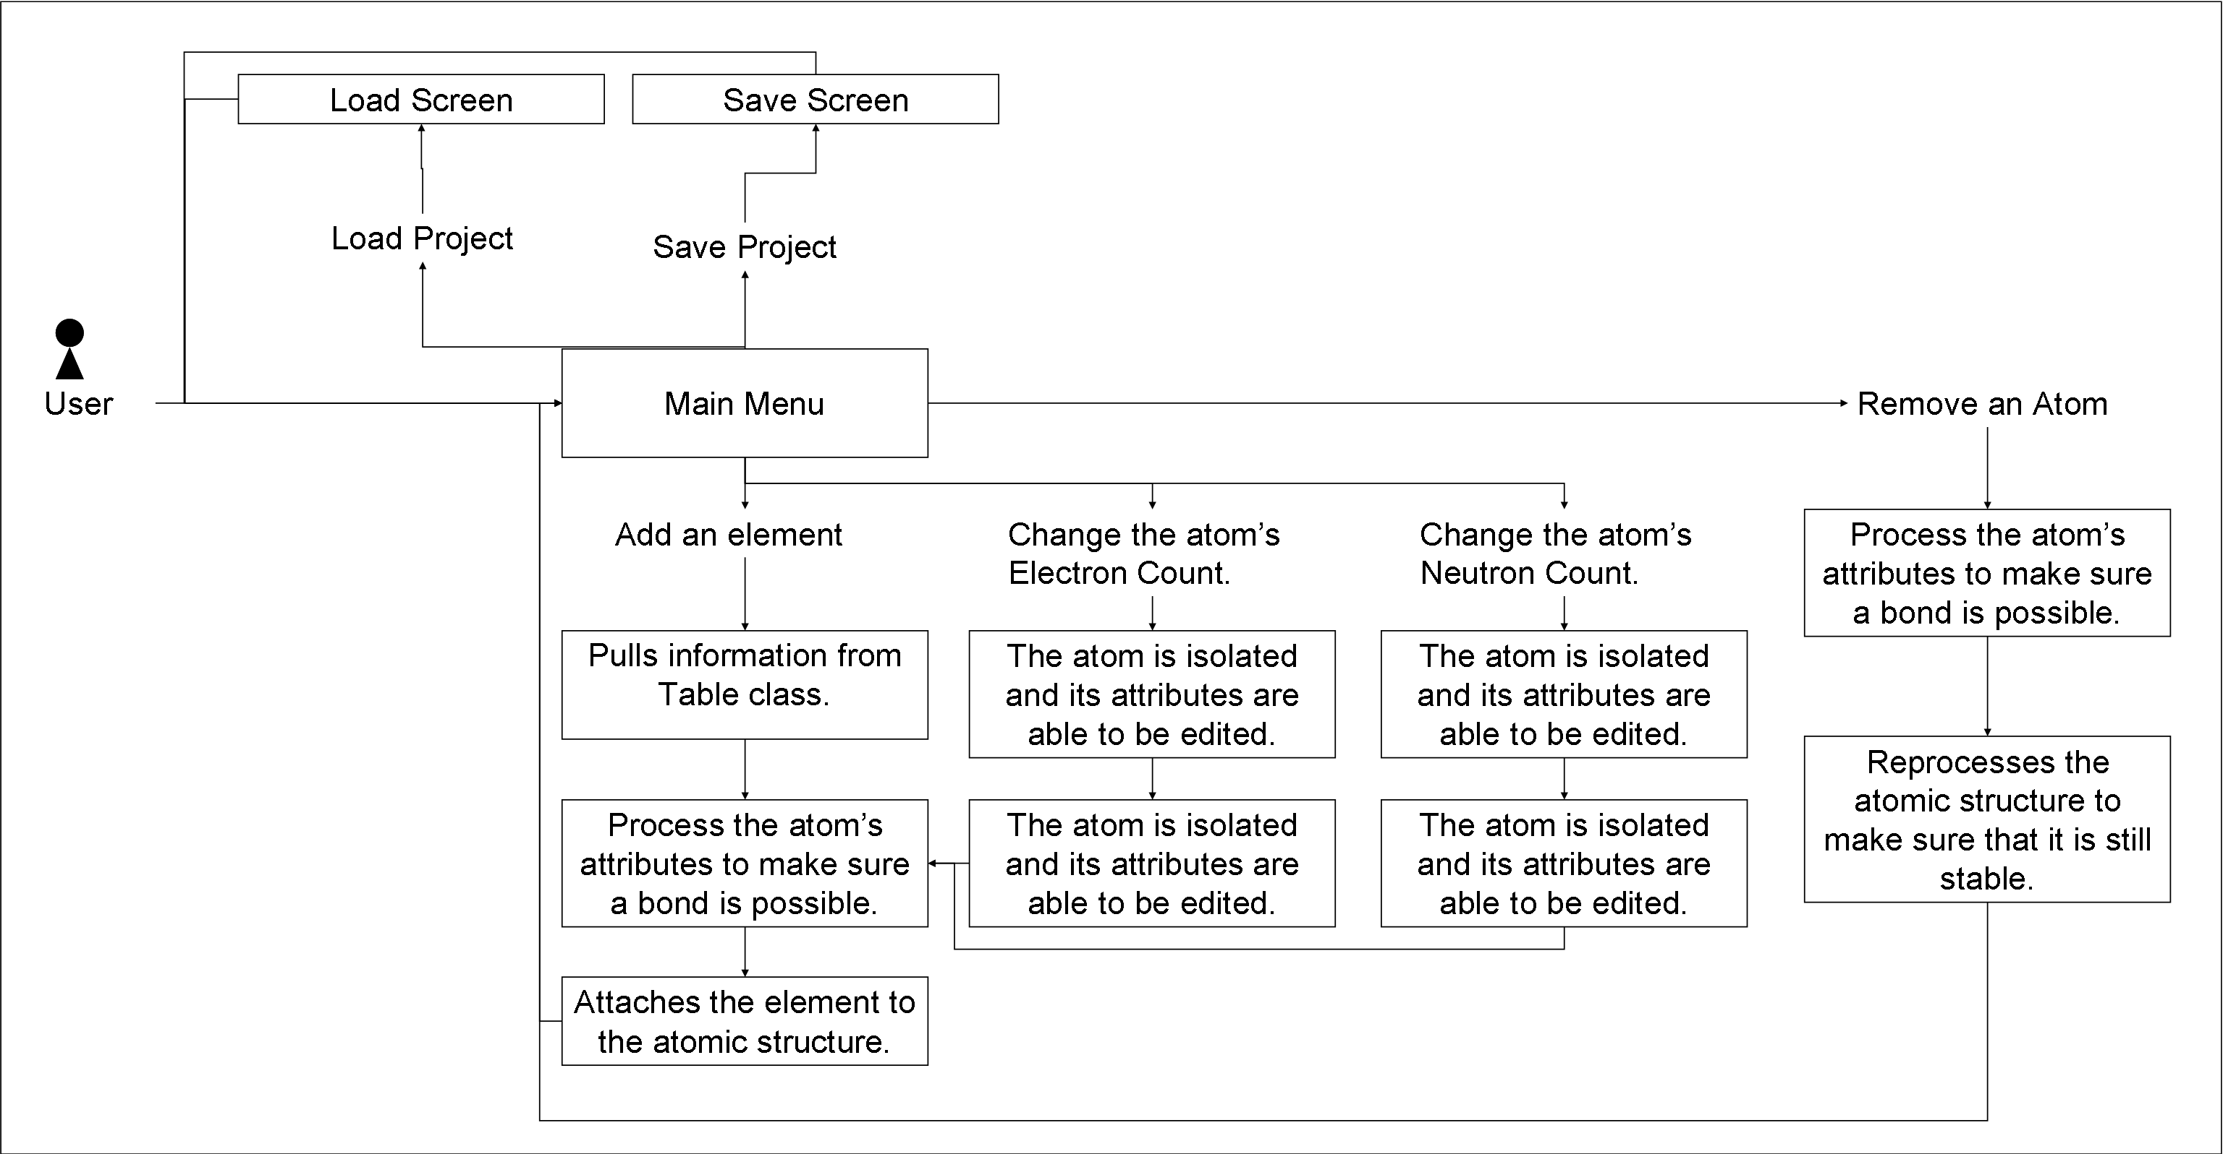

User Interface Design

Main Menu:

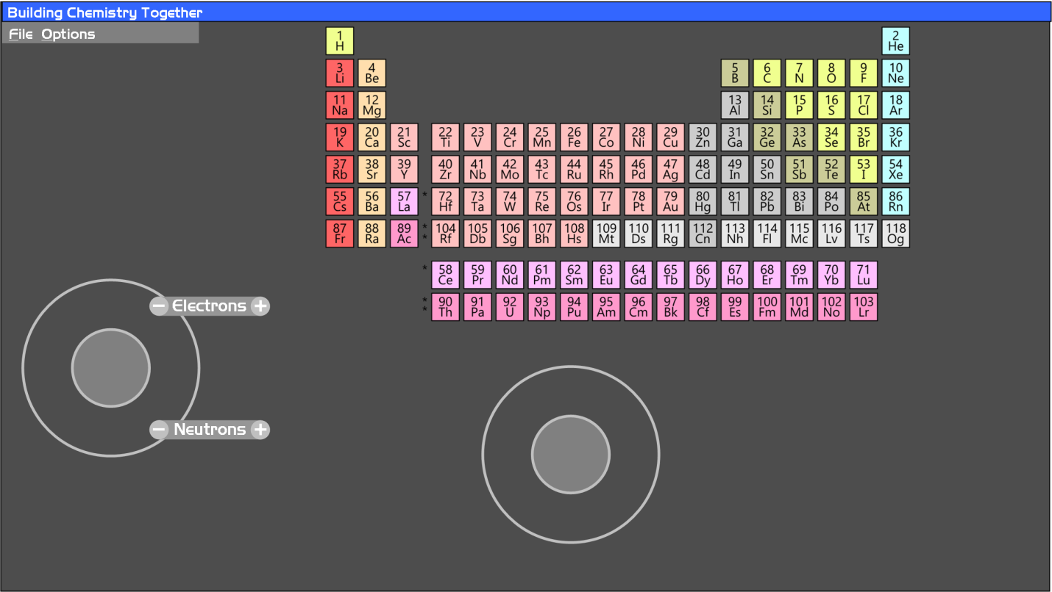

Drop Down Menus:

**Options.tif**

Image Export Menu:

